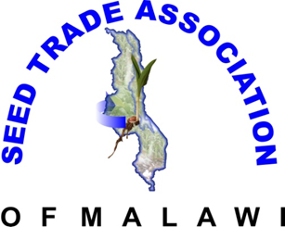
29 September, 2017
- Annual General Meeting: Election Paper.
Instructions: One member one Vote
Please Tick candidate of your choice
________________________________________________________
1 A. Chairman
- John Lungu - Quton
1B. Vice Chairman
- Dr Francis Maiden - Demeter
2A. Secretary General
- Nessimu Nyama- ASSMAG
- Steve Kamwendo – Funwe
2B Vice Secretary General
- Hannock Madeira- Syngenta
- Clemence C. Gondwe – MSI
3. Treasure General
- Dalitso Gadama – Monsanto
4. Committee Members
- Martha Nkhoma- Vilerishama
- Mrs V.C Phiri – ARET
- Shane Phiri – Global Seeds
- AlexenaderChikapula- NASFAM
- Mr Dellings Phiri- Universal Seeds
- Innocent Jumbe – Peacock Seeds

